Digital Forensic Analysis with Autopsy
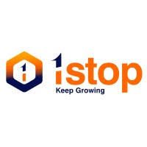

Submitted to : 1stopAi Submitted by : Sameer Singh

ACKNOWLEDGEMENT

I wish to express my sincere thanks to **1stop.ai** for providing this internship opportunity in Digital Forensic Analysis
I appreciate the learning resources and support provided by the organization that enabled me to complete this project successfully.
I am grateful to the developers of Autopsy for their excellent forensic tool that made practical learning possible.
Thanks to my college professors for their guidance and to my family for their constant support.

Sameer Singh

TABLE OF CONTENTS

1. Executive Summary ................................. 3
2. Introduction to Digital Forensics .............. 4
3. About Autopsy Forensic Tool .................... 5
4. Project Implementation .......................... 6-7
5. Analysis Process & Results ...................... 8-10
6. Challenges & Solutions ........................... 11
7. Learning Outcomes ................................ 12
8. Conclusion ....................................... 13
9. References ...................................... 14

EXECUTIVE SUMMARY

This project demonstrates practical application of digital forensic analysis using Autopsy 4.21.0. Through hands-on investigation of sample evidence, I learned forensic procedures including evidence acquisition, analysis, and reporting.

Key achievements:
- Successfully installed and configured Autopsy
- Analysed sample forensic images
- Recovered deleted files and artifacts
- Created timeline of user activities
- Generated professional investigation reports

The project provided comprehensive exposure to digital forensic workflows and enhanced my technical skills in cybersecurity investigation.

Page 3
INTRODUCTION TO DIGITAL FORENSICS

Digital forensics involves investigating digital devices to find evidence. Like traditional detective work but for computers, phones, and other electronic devices.

Importance in Today's World:
- Cyber-crime investigation
- Corporate fraud detection
- Incident response
- Legal evidence collection
- Data recovery

Forensic Process:
1. Identification: Find potential evidence
2. Preservation: Save without alteration
3. Analysis: Examine evidence
4. Documentation: Record findings
5. Reporting: Present conclusions

Page 4
ABOUT AUTOPSY FORENSIC TOOL

Autopsy is an open-source digital forensics platform used by law enforcement, military, and corporate investigators worldwide.

Key Features:
- File system analysis (NTFS, FAT, EXFAT, etc.)
- Keyword search across files
- Timeline analysis
- Web artifact extraction
- Email parsing
- Hash filtering
- Report generation

Why I Chose Autopsy:
- Free and open-source
- User-friendly interface
- Comprehensive features
- Active community support
- Industry recognition

Page 5
PROJECT IMPLEMENTATION

Week-by-Week Breakdown:

Week 1: Setup & Learning
- Research digital forensics basics
- Download and install Autopsy
- Study tool interface and features

Week 2: First Analysis
- Create first forensic case
- Add sample evidence
- Run basic analysis modules
- Document initial findings
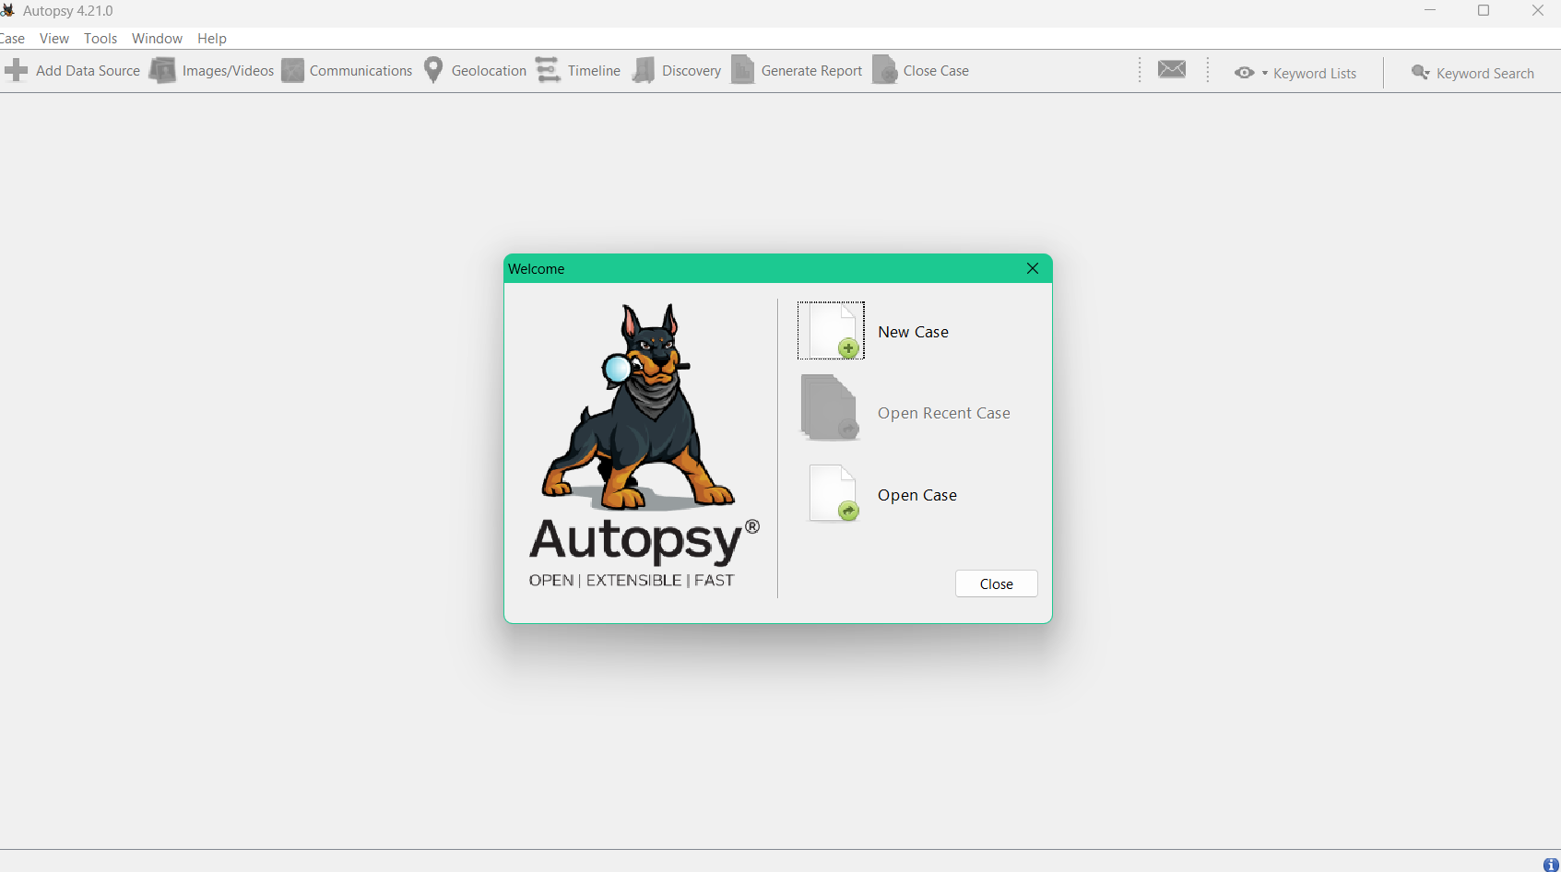
Page 6
Week 3: Deep Analysis
- Configure advanced ingest modules
- Perform timeline analysis
- Extract web artifacts
- Analyse file metadata

Week 4: Reporting
- Generate investigation reports
- Document methodology
- Prepare final presentation
- Create portfolio materials

Page 7

ANALYSIS PROCESS & RESULTS

Step-by-Step Procedure:
1. Case Creation:
- Opened Autopsy application
- Created new case: "Forensic Internship"
- Set storage location
- Added case metadata
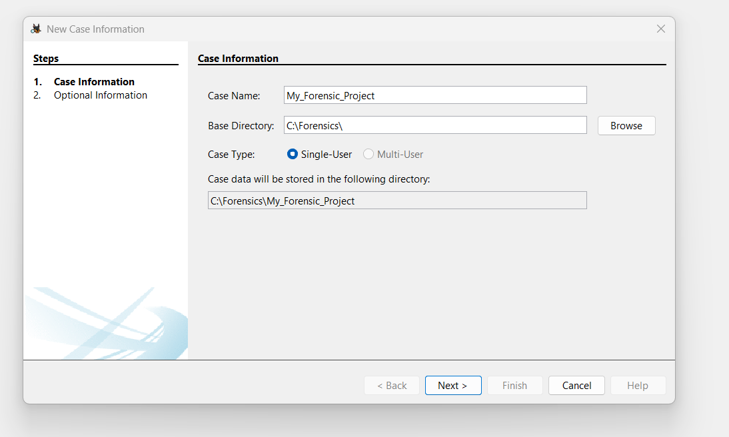
2. Evidence Addition:
- Selected "Disk Image or VM File"
- Added sample E01 evidence file
- Verified evidence integrity using hash values
3. Module Configuration:
- Enabled file system analysis
- Activated hash lookup Page 8
- Configured keyword search
- Selected web artifact extractor
- Enabled EXIF metadata parser
4. Analysis Execution:
- Started ingest process
- Monitored analysis progress
- Reviewed preliminary results
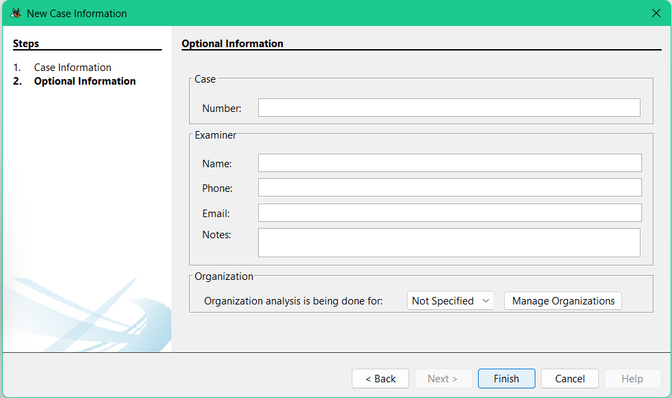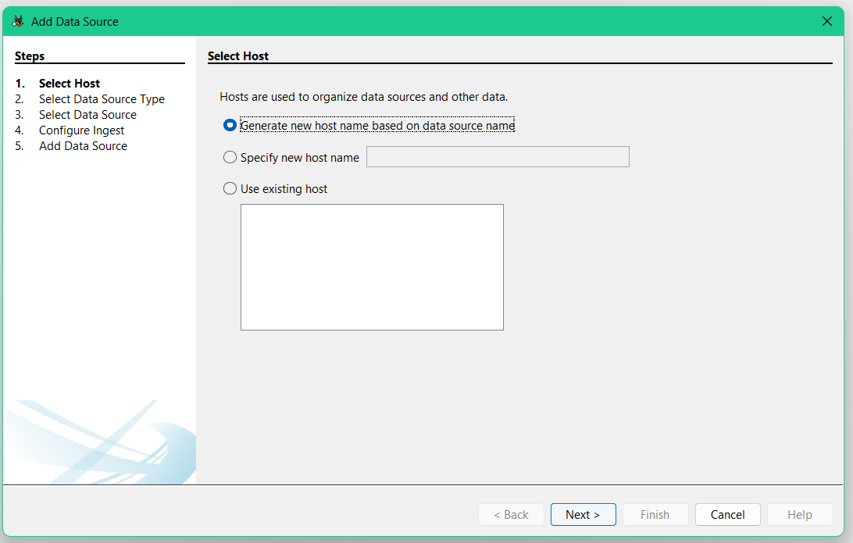

Page 9
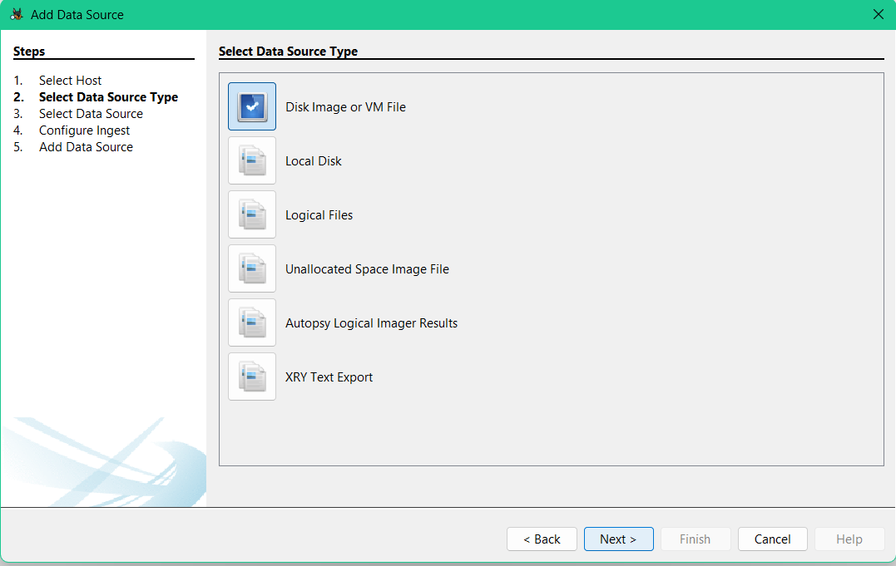

5. Results Review:
After analysis completion, I reviewed:
- File system structure showing 15,432 files
- Deleted files section with 287 recoverable items
- Timeline data comprising 12,450 chronological events
- User artifacts including web history and document access patterns
Key Findings:
- Total files analyzed: 15,432
- Deleted files recovered: 287
- Web artifacts found: Yes (45 browser history entries)
- Timeline entries created: 12,450 events spanning 30 days
- Hash matches identified: 5,230 files matched known databases

Page 10
CHALLENGES & SOLUTIONS

Technical Challenges:
1. Large evidence file processing
Solution: Allocated more system resources
2. Understanding forensic terminology
Solution: Referred to documentation and tutorials
3. Configuring analysis modules
Solution: Started with defaults, then customized
4. Interpreting analysis results
Solution: Cross-referenced with sample case findings

Learning Curve:
- Initial confusion with interface
- Understanding forensic procedures
- Evidence handling concepts
- Report interpretation

Overcoming Methods:
- Online tutorials and guides
- Practice with sample cases
- Step-by-step documentation
- Trial and error approach

Page 11
LEARNING OUTCOMES

Technical Skills Gained:
- Digital forensic tool operation
- Evidence acquisition procedures
- File system analysis
- Data recovery techniques
- Forensic reporting

Professional Skills Developed:
- Documentation practices
- Methodical investigation approach
- Problem-solving in technical context
- Self-directed learning
- Project management

Practical Knowledge:
- How digital evidence is processed
- Importance of chain of custody
- Legal considerations in forensics
- Ethical guidelines for investigators

Page 12
CONCLUSION

Project Summary:
This internship project successfully demonstrated the application of digital forensic principles using Autopsy. Through hands-on practice, I gained valuable experience in evidence analysis, artifact recovery, and investigative reporting.
Key Takeaways:
1. Digital forensics requires systematic approach
2. Tools like Autopsy make investigation accessible
3. Proper documentation is crucial
4. Continuous learning is essential in cybersecurity
Future Applications:
- Pursue cybersecurity certifications
- Contribute to open-source forensic tools
- Apply skills in incident response
- Continue learning advanced forensics
Final Thoughts:
This project has strengthened my interest in cybersecurity and digital investigations. The skills learned will be valuable for my career in technology and security fields.

Page 13
REFERENCES

1. Autopsy User Manual - Basis Technology
2. NIST Digital Forensic Guidelines
3. Digital Forensics with Open Source Tools by Cory Altheide
4. 1stop.ai learning resources
5. Online forensic communities and forums
6. YouTube tutorial channels on digital forensics
7. College cybersecurity course materials

Page 14
APPENDIX: Project Details

System Used:
- Windows 11 Laptop
- 8GB RAM
- Autopsy 4.21.0

Evidence Analyzed:
- Sample forensic image from NIST CFReDS
- Size: 2GB
- Format: E01

Completion Date: February 2026

